4C MODEL
Context Level
At the highest level, the Context level, we describe the system’s external environment, such as users, other systems, regulations, etc. This level provides a high-level overview of the system’s purpose and its relationship to the external world. It helps to identify the stakeholders who will interact with the system and the factors that will influence its design and development.
Containers level
The next level is the Containers level, which describes the runtime environment of the system, such as servers, databases, or message queues. This level helps to identify the major technology choices and deployment decisions. It provides an understanding of the physical infrastructure that will support the system and the tools and resources that will be required to deploy and maintain it.
Components level
The third level is the Components level, which describes the major functional building blocks of the system. This level helps to identify the modules, classes, or functions that make up the system. It provides an understanding of the system’s functionality and the relationships between its different components.
Code level
Finally, the Code level is the lowest level, which describes the actual code and how it implements the components. This level provides a detailed understanding of how the system works and how its different components interact with each other. It is essential for developers who will be working with the code to have a clear understanding of how it is structured and how it works.
Using the C4 model, software architects can create diagrams and written documentation that describe each of these levels, providing a comprehensive view of the system’s architecture. This approach helps to identify potential issues and trade-offs, as well as facilitating scalability, maintainability, and adaptability. By documenting the architecture in this way, developers and stakeholders can have a clear and easy-to-understand view of the system, making it easier to modify and extend as business needs change.
- Mono-Lithic Architecture
Monolithic architecture is a traditional software design model where all application components, such as the user interface, business logic, and data access, are built as a single, unified unit with a single codebase. This "all-in-one" approach can simplify initial development and deployment for small projects, but it becomes restrictive as the application grows, making it difficult to scale individual components, recompile the entire application for small changes, and manage complex codebases.
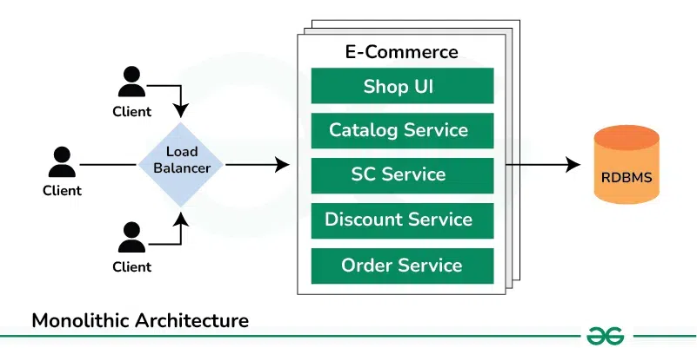
Self-Read!
A load balancer distributes incoming network or application traffic across a group of healthy servers, acting as a "traffic cop" to prevent any single server from becoming overwhelmed.
Can we used load balancer in monolithic architecture?
Yes, load balancers can be used effectively in a monolithic architecture. While often associated with microservices for distributing traffic across numerous independent services, load balancers are equally valuable for scaling and ensuring high availability of monolithic applications.
How Load Balancers are used in Monolithic Architecture:
Horizontal Scaling:
A load balancer enables the deployment of multiple instances of the same monolithic application on different servers. It then distributes incoming client requests across these instances, preventing any single server from becoming a bottleneck and improving overall application performance and capacity.
Key Characteristics
Single Codebase: All application functions reside within one codebase.
Unified Unit: The entire application functions as a single, self-contained unit.
Tightly Coupled Components: Components are tightly connected, meaning a change in one can impact others.
Single Deployment: The entire application is deployed as one deployable entity.
Shared Memory: Monolithic applications typically share the same memory space, allowing components to communicate efficiently without the need for network overhead.
Advantages
Simplicity: Easy to develop, manage, and deploy, especially for small applications or startups.
Initial Speed: Faster to get started with because there's no need to coordinate multiple services.
Reduced Overhead: Lower overhead for certain applications, making them suitable for resource-constrained devices.
Security: With fewer inter-service communication points, monolithic systems may have a reduced attack surface, making them potentially more secure, especially if proper security measures are implemented.
Legacy Support: Many existing systems still rely on monolithic architectures. Maintaining and evolving these systems requires expertise, and understanding monolithic architectures is crucial for their continued operation.
Disadvantages
Scalability Issues: You must scale the entire application even if only one feature needs more resources, which is inefficient.
Rigidity & Difficulty in Updates: Requires recompiling and redeploying the entire application for even minor changes, making updates slow and cumbersome.
Complexity: As the codebase grows, it becomes difficult to understand, manage, and onboard new developers.
Technology Limitations: Difficult to adopt new technologies for parts of the application without rewriting the entire system.
Widespread Impact of Failures: A bug in one part of the codebase can bring down the entire application.
When to Use
Monolithic architectures are well-suited for small-to-medium-sized applications where the entire system is straightforward, or when a project is in its early stages and needs rapid iteration.
What are Distributed Systems?
Distributed Systems are networks of independent computers that work together to present themselves as a unified system. These systems share resources and coordinate tasks across multiple nodes, allowing them to work collectively to achieve common goals. Key characteristics include:
Multiple Nodes: Consists of multiple interconnected computers or servers that communicate over a network.
Resource Sharing: Enable sharing of resources such as processing power, storage, and data among the nodes.
Scalability: This can be scaled by adding more nodes to handle increased load or expand functionality.
Fault Tolerance: Designed to handle failures of individual nodes without affecting the overall system’s functionality.
Transparency: Aim to hide the complexities of the underlying network, making the system appear as a single coherent entity to users.
Architecture Styles in Distributed Systems
To show different arrangement styles among computers Architecture styles are proposed.
B. Service-Oriented Architecture (SOA) in Distributed Systems
Service-Oriented Architecture (SOA) is a design paradigm in distributed systems where software components, known as "services," are provided and consumed across a network. Each service is a discrete unit that performs a specific business function and communicates with other services through standardized protocols.
- In SOA, the system is structured as a collection of services that are loosely coupled and interact through well-defined interfaces. These services are independent and can be developed, deployed, and managed separately.
- They communicate over a network using standard protocols such as HTTP, SOAP, or REST, allowing for interoperability between different systems and technologies.
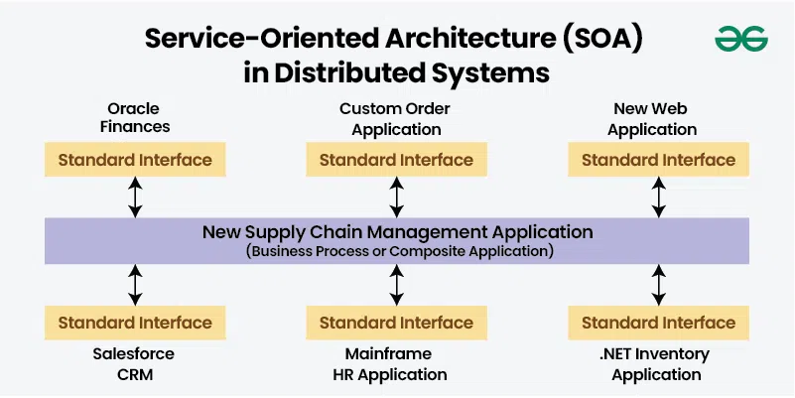

Key Principles of Service-Oriented Architecture (SOA) in Distributed Systems
- Loose Coupling:
  - Function: Services are designed to be independent, minimizing dependencies on one another. Changes to one service do not affect others, enhancing system flexibility and maintainability.
- Service Reusability:
  - Function: Services are created to be reused across different applications and contexts. Reduces duplication of functionality and effort, improving efficiency and consistency.
- Interoperability:
  - Function: Facilitates communication between diverse systems and platforms, enabling integration across heterogeneous environments.
- Single Data Base
- Abstraction:
  - Function: Services expose only necessary interfaces and hide their internal implementation details. Simplifies interactions between services and reduces complexity for consumers.
Advantages and Disadvantages of Service-Oriented Architecture (SOA) in Distributed Systems
- Advantages:
  - Flexibility: Up to certain extent, allows loose coupling for easier changes and updates to services without impacting the overall system.
  - Reusability: Up to some extent, Services can be reused across different applications, reducing redundancy and development effort.
  - Scalability: Unlike Monolithic, Services can be scaled independently, supporting dynamic load balancing and efficient resource utilization.
  - Interoperability: Standardized protocols enable integration across various platforms and technologies, fostering collaboration and data exchange.
- Disadvantages:
  - Complexity: Managing multiple services and their interactions can introduce complexity, requiring effective governance and orchestration.
  - Performance Overhead: Communication between services over a network can introduce latency and overhead, affecting overall system performance.
  - Security: Ensuring secure communication and consistent security policies across multiple services can be challenging.
  - Network Latency: ?? Describe in your words
  - Deployment and Maintenance: Deploying and maintaining a distributed collection of services requires robust infrastructure and management practices.
Examples and Use Cases of Service-Oriented Architecture (SOA) in Distributed Systems
- Enterprise Systems: SOA is commonly used to integrate various enterprise applications such as ERP, CRM, and HR systems, allowing them to work together seamlessly.
- Web Services: Many modern web applications leverage SOA principles to interact with external services via APIs, enabling functionalities such as payment processing, data retrieval, and authentication.
C. Micro-services Architecture for Distributed Systems
Micro-services Architecture is a design pattern where an application is composed of small, independent services that each perform a specific function. These services are loosely coupled and interact with each other through lightweight communication protocols, often over HTTP or messaging queues.
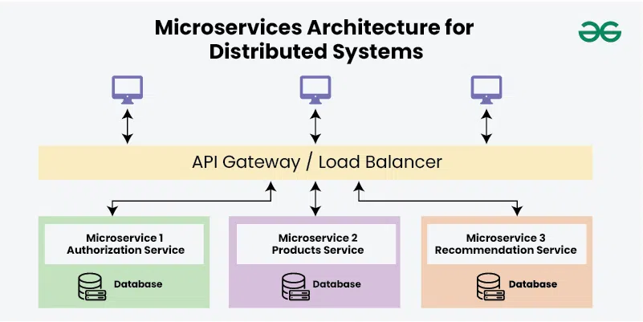
Key Principles of Micro-services Architecture for Distributed Systems
- Single Responsibility: Each micro-service focuses on a single business capability or function, enhancing modularity.
- Autonomy: Micro-services are independently deployable and scalable, allowing for changes and updates without affecting other services.
- Decentralized Data Management: Each micro-service manages its own data, reducing dependencies and promoting scalability.
- Inter-service Communication: Services communicate through well-defined APIs or messaging protocols.
Advantages and Disadvantages of Micro-services Architecture for Distributed Systems
- Advantages:
  - Scalability: Services can be scaled independently based on demand, improving resource utilization.
  - Resilience: Failure in one service does not necessarily impact others, enhancing system reliability.
  - Deployment Flexibility: Micro-services can be developed, deployed, and updated independently, facilitating continuous delivery.
  - Reusability: ?? Describe in your words
  - Multiple Framworks: ?? Describe in your words
- Disadvantages:
  - Complexity: Managing multiple services and their interactions can be complex and requires effective orchestration.
  - Data Consistency: Ensuring data consistency across services can be challenging due to decentralized data management.
  - Network Overhead: Communication between micro-services can introduce latency and require efficient handling of network traffic.
Examples of Micro-services Architecture for Distributed Systems
- E-Commerce Platforms: Platforms like Amazon use microservices to handle different aspects of their operations, such as user authentication, payment processing, and order management.
- Streaming Services: Companies like Netflix employ microservices to manage different functionalities, such as recommendation engines, content delivery, and user interfaces.
- Financial Services: Banks and financial institutions use microservices to manage various functions, including transaction processing, customer management, and compliance.

D. Client Server Architecture in Distributed Systems
Client-Server Architecture is a foundational model in distributed systems where the system is divided into two main components: clients and servers. This architecture defines how tasks and services are distributed across different entities within a network.
- In Client-Server Architecture, clients request services or resources, while servers provide those services or resources.
- The client initiates a request to the server, which processes the request and returns the appropriate response.
- This model centralizes the management of resources and services on the server side, while the client side focuses on presenting information and interacting with users.
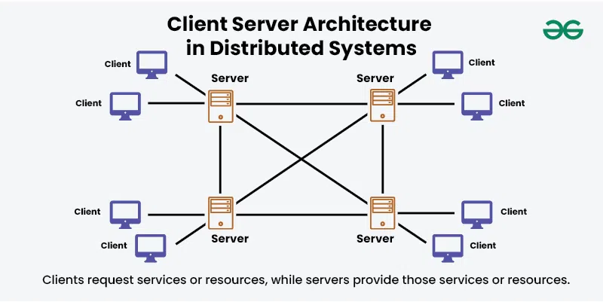

Key Principles of Client Server Architecture in Distributed Systems
- Separation of Concerns:
Clients handle user interactions and requests, while servers manage resources, data, and business logic.
- Centralized Management:
Servers centralize resources and services, making them accessible to multiple clients.
- Request-Response Model:
Clients send requests to servers, which process these requests and send back responses. It uses s a communication pattern where the client and server interact through a well-defined protocol, often using HTTP or similar standards.
- Scalability:
Servers can be scaled to handle increasing numbers of clients or requests.
- Security:
Security mechanisms are often implemented on the server side to control access and manage sensitive data, making it easier to enforce and manage security measures.
- Server becomes a client explain in your own words

Advantages and Disadvantages of Client Server Architecture in Distributed Systems
- Advantages:
  - Centralized Control: Easier to manage and update resources and services from a central location.
  - Simplified Maintenance: Updates and changes are made on the server side, reducing the need for client-side modifications.
  - Resource Optimization: Servers can be optimized for performance and reliability, serving multiple clients efficiently.
  - Security Management: Centralized security policies and controls make it simpler to protect resources and data.
- Disadvantages:
  - Single Point of Failure: Servers can become a single point of failure, impacting all connected clients if they go down.
  - Scalability Challenges: Handling a large number of client requests can overwhelm servers, requiring careful load management and scaling strategies.
  - Network Dependency: Clients depend on network connectivity to access server resources, which can impact performance and reliability.
  - Performance Bottlenecks: High demand on servers can lead to performance bottlenecks, requiring efficient resource management and optimization.

Examples of Client Server Architecture in Distributed Systems
- Web Applications: In a typical web application, web browsers (clients) request web pages or data from web servers.
- Email Systems: Email clients connect to email servers to send, receive, and manage email messages.
- Database Access: Database clients request data and perform queries on database servers.
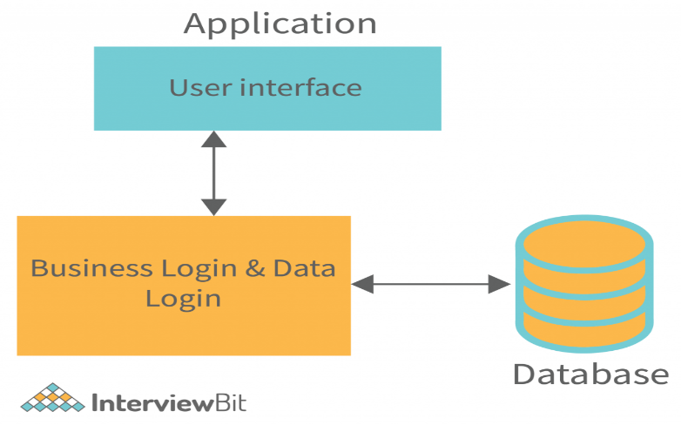
Types of Client-Server Architecture

    - 1-Tier Architecture
1 Tier Architecture is the simplest architecture of Database in which the client, server, and Database all reside on the same machine. A simple one tier architecture example would be anytime you install a Database in your system and access it to practice SQL queries. But such architecture is rarely used in production. While useful in many ways, 1-tier tend to create a lot of data, which means applications require significant, frequent management. When left unmanaged, data variances will eventually corrupt the results and interfere with performance.
For Example: to learn SQL we set up an SQL server and the database on the local system.
Simple Architecture: 1-Tier Architecture is the simplest architecture to set up, as only a single machine is required to maintain it.
Cost-Effective: No additional hardware is required for implementing 1-Tier Architecture, which makes it cost-effective.
Easy to Implement: 1-Tier Architecture can be easily deployed, and hence it is mostly used in small projects.

    - 2-Tier Architecture
A 2 Tier Architecture is an architecture where the presentation layer runs on a client (PC, Mobile, Tablet, etc.), and data is stored on a server called the second tier. Two tier architecture provides added security to the DBMS as it is not exposed to the end-user directly. It also provides direct and faster communication. In comparison to 1-tier architectures, 2-tier architectures are faster since there is no intermediary between the client and the server. The 2-tier architecture helps avoid client confusion. The online reservation system is a popular example of a 2-tier architecture.
Easy to Access: 2-Tier Architecture makes easy access to the database, which makes fast retrieval.
Scalable: We can scale the database easily, by adding clients or upgrading hardware.
Low Cost: 2-Tier Architecture is cheaper than 3-Tier Architecture and Multi-Tier Architecture.
Easy Deployment: 2-Tier Architecture is easier to deploy than 3-Tier Architecture.
Simple: 2-Tier Architecture is easily understandable as well as simple because of only two components.
    - 3-Tier Architecture
A 3 Tier Architecture in DBMS is the most popular client server architecture in DBMS in which the development and maintenance of functional processes, logic, data access, data storage, and user interface is done independently as separate modules. Three Tier architecture contains a presentation layer, an application layer, and a database server.
3-Tier database Architecture design is an extension of the 2-tier client-server architecture. A 3-tier architecture has the following layers:
Presentation layer (your PC, Tablet, Mobile, etc.)
Application layer (APIs)
Database Server In 3-tier architecture, there are three main layers: presentation layer, application layer, and database layer. Different ends of each layer control each other. Client devices control the presentation layer, whereas the middleware and server control the application layer and database layer, respectively. The existence of a third layer that provides data control makes the 3-tier architecture more secure, has invisible database structures, and ensures data integrity.

This intermediate layer acts as a medium for the exchange of partially processed data between the server and the client. This type of architecture is used in the case of large web applications.

• Enhanced scalability: Scalability is enhanced due to the distributed deployment of application servers. Now, individual connections need not be made between the client and server.
• Data Integrity: 3-Tier Architecture maintains Data Integrity. Since there is a middle layer between the client and the DB, data corruption can be avoided/removed.
• Security: 3-Tier Architecture Improves Security. This type of model prevents direct interaction of the client with the server thereby reducing access to unauthorized data.
• More Complex: 3-Tier Architecture is more complex in comparison to 2-Tier Architecture. Communication Points are also doubled in 3-Tier Architecture.
Important Note:
API : An API, which stands for application programming interface, is a set of protocols that enable different software components to communicate and transfer data. Developers use APIs to bridge the gaps between small, discrete chunks of code in order to create applications that are powerful, resilient, secure, and able to meet user needs.
APIs (or Application Programming Interfaces) have become the backbone of modern software development. They allow different applications and systems to communicate with each other, enabling seamless data exchange and functionality integration. However, managing and securing these APIs can be a daunting task. This is where API Gateways come into play.

What is an API Gateway?
It stands between the clients (such as mobile apps or web applications) and your backend services, ensuring that only authorized requests get through
Role in Micro services Architecture
As a gatekeeper that ensures only authorized requests get through, API Gateway plays a pivotal role.
First and foremost, an API Gateway simplifies the complex world of APIs. Instead of clients having to navigate a maze of different API endpoints, they interact with the API Gateway as a single, user-friendly entry point. It’s like having a friendly receptionist who directs you to the right restaurant table instead of you wandering through the entire dining area.
Beyond simplification, an API Gateway has several other important roles. It’s a traffic controller, guiding incoming API requests to the appropriate backend services. It checks if the client making the request is allowed access by verifying their credentials and permissions, just like a vigilant security guard. It also assists with request transformation if needed, making sure that data is exchanged in the right format.
An API gateway centralizes and manages access to your APIs, while a load balancer efficiently distributes incoming traffic across multiple servers.

